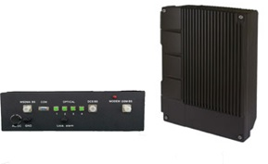
LTE - iDEN - TETRA- APCO-25 SMR 800MHz 10W Digital Fiber Optic Repeater System
Model No: DFBDA-850-40W55

Feature
- Supports LTE, WCDMA, iDEN, TETRA, APCO25 at the SMR 850MHz band
- High power linear amplifier, designed for outdoor or in-building coverage
- Advanced digital technology to support multi carrier scenarios
- Support multi operator scenario when sharing same antenna system
- High stability and long life cycle
- Energy-efficient design, power saving
Introduction
The EMTS Telecom Services Ltd. LTE800 - iDEN800 Fiber Optic Repeater is the perfect solution for network optimization in mobile network that can enlarge the BTS coverage. It is widely used in the shaded area, high traffic load area and the pilot pollution area, etc.
How does it work
The master unit of TX/RX receives the downlink (DL) signal from BTS through the DL Amplifier and Input Power Detection. The RF signal is converted to IF signal by using a mixer. The IF signal is transformed into digital signal by digital module, which uses special technology of D/A conversion, digital down-conversion and digital filtering. The digital optical signal is transmitted via Master optic unit and its fiber to the Remote unit, in which digital optic signal is converted back (Digital filtering, digital Up-conversion and A/D conversion) to RF signal via remote unit. The RF signal is then amplified in the DL-AMP (Amplifier) and PA (Power Amplifier) to meet a required output power level and then to remote DL filter and transmit at port of “To Service (TX) port”. The Uplink RF signal of the mobile terminals in the coverage area is connected via an antenna port and is filtered by duplexer and amplified by the ULNA (Uplink Low Noise Amplifier).
Same as in the Downlink path, using a mixer to convert the UL RF signal to IF signal, which is converted to digital optical signal by using technologies of D/A conversion, digital down-conversion and digital filtering. The digital optical signal is then transmitted via master optic unit and fiber to remote unit, in which optic signal converted back to RF(Digital filtering , digital Up-conversion and A/D conversion) signal then amplified , flittered by the UL AMP (Amplifier) and duplexer, after all processing stages, the signal are to be transmitted at via the donor/ Rx Port.
The main controlling panel (PCM) of the master and remote units is controlling their modules and communicate with each other via the data link of the optic modules. User can inquire and set the parameters by LOC (local monitoring) interface on the master/remote unit. and user also can do in the OMC (Operation and Maintenance Center) by IP network. Power supply unit - supplies power to all the active modules and in charge of charging battery.

System Diagram
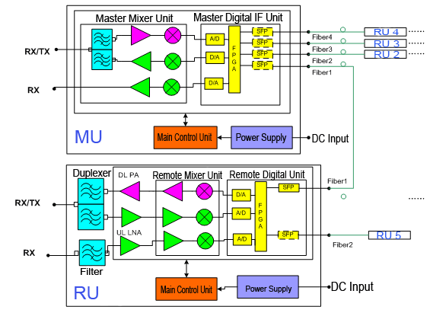

System Applications
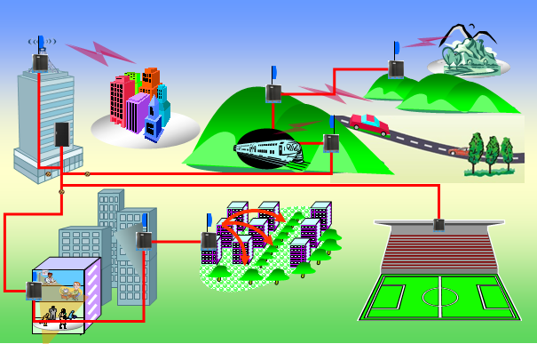

Electrical Specifications:
Feature |  | Downlink | Uplink
Frequency Range |  | 851-869MHz | 806-824MHz
Gain (Max.) |  | 55±3dB | 50±3dB
Output Power (Max.) |  | 40dBm±1dB | 0dBm±1dB
Gain adjustable range/step |  | ≥30dB/1dB
Gain Adjustable Error |  | Gain adjustable range is 0-20dB, error≤±1dB; ≥21dB, error≤±1.5dB
ALC |  | When adding ≤10dB at max. output level, output variation ≤±2dB, when adding >10dB, output variation ≤±2dB or turnoff.
VSWR |  | ≤1.5
Ripple in Band |  | ≤3.0dB
Group delay |  | Repeater delay: ≤18μs(One with one, Fiber optical pigtail 1m);  System delay: ≤25μs(One with six, Fiber optical pigtail 1m);  Delay compensation range: ≥100μs automatic or manually compensation; Delay calibration step: ≤1μs;
ALC |  | When adding ≤10dB at max. output level, output variation ≤±2dB,  when adding >10dB, output variation ≤±2dB or be off.
Noise Figure |  | <5dB (only for uplink)
Out-band gain | ≥400kHz | ≥56dB
Out-band gain | ≥600kHz | ≥60dB
Out-band gain | ≥1MHz | ≥60dB
Out-band gain | ≥5MHz | ≥65dB
IMD | In-Band | ≤-45dBc
IMD | Out-Band | 9kHz-1GHz≤-36dBm/100kHz
IMD | Out-Band | 1GHz-12.75GHz≤-30dBm/1MHz
Spurious emission |  | 9kHz-1GHz≤-36dBm/100kHz
 |  | 1GHz-12.75GHz≤-30dBm/1MHz
Blocking |  | F1 -20MHz-F1-2.5MHz: -40dBm/ GSM signal
 |  | F2 +2.5MHz-F2+20MHz: -40dBm/ GSM signal
 |  | 100kHz-F1-20MHz: 0dBm/ CW signal
 |  | F2+20MHz-12.75GHz: 0dBm/ CW signal
 |  | 1805MHz-1880MHz（Except1800MHz Downlink）
 |  | 1880MHz-1920MHz / 2010MHz-2025MHz / 2110MHz-2170MHz / 2300MHz-2400MHz / 2400MHz-2483.5MHz / 2500MHz-2690MHz / 3300MHz-3600MHz / 806MHz-835MHz: 0dBm/ CW signal
 |  | 1880MHz -1920MHz/1920MHz-1980MHz: 0dBm/ CW signal

Mechanical Specifications
Power Supply | Master unit: DC -48V±9.6V or AC: 90-270V  Remote unit: AC 110V/220V, 45~60Hz
Dimension and Weight | Master Unit: 482.6*43.6*365mm, ≤10kg  Remote Unit: 520*380*151mm, ≤20kg
Max. Power Consumption | Master Unit: ≤90W | Remote Unit: ≤120W
Operating Temperature | Master Unit: 0 to +45℃ | Remote Unit: -25 to +55℃
Operating Humidity | Master Unit: ≤85% | Remote Unit: ≤95%
Environmental Class | Master Unit: IP30 | Remote Unit: IP65
RF Connector | N-Female, 50ohm
MTBF | ≥50000 hours
Monitor Interface | Local Monitor: TCP/IP or RS232, Remote Monitor: TCP/IP or Modem SMS

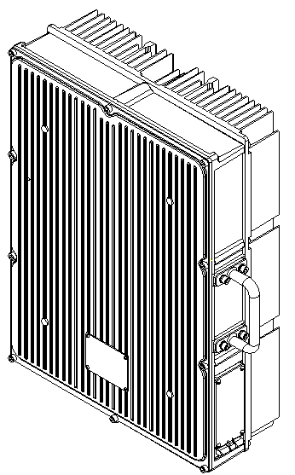
Products outlook:

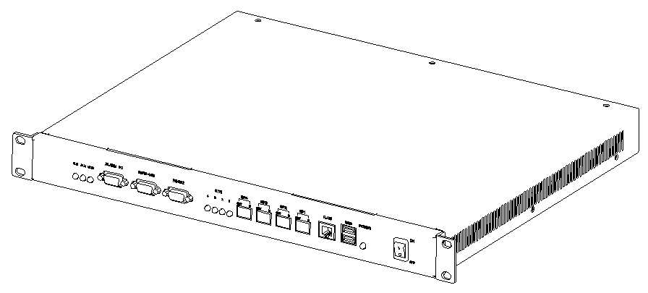

Master Unit Remote Unit
P/N: FBB-850-L-I P/N: FBR-850-40W40-L-I

Note: All specifications subject to change without notice.

